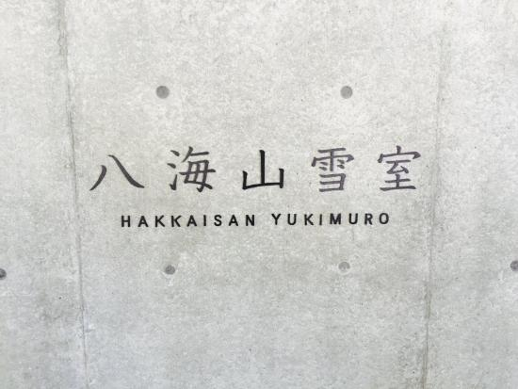

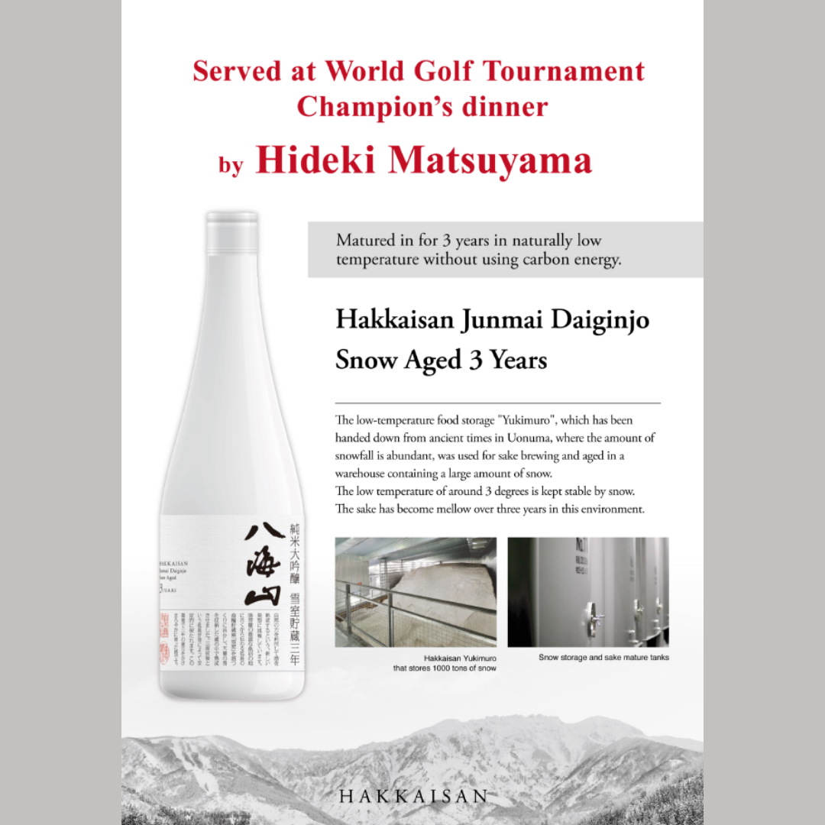


House Sake

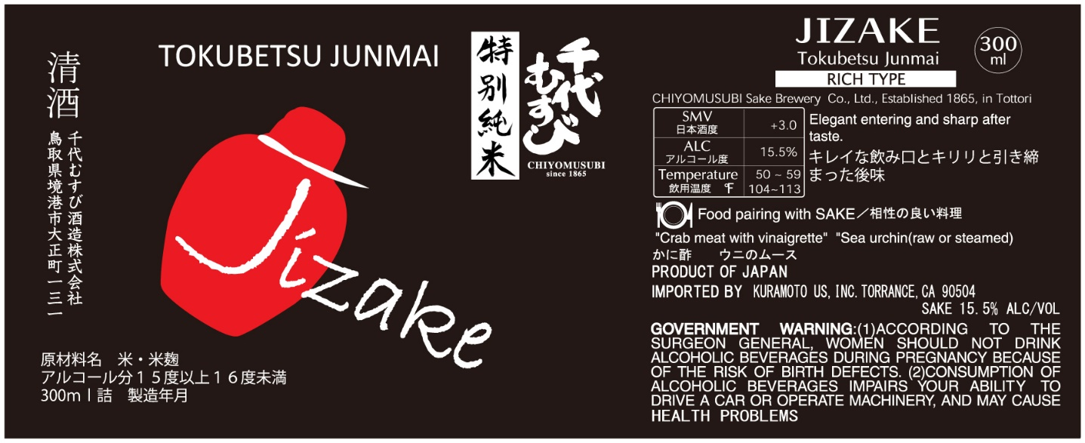

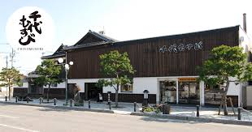

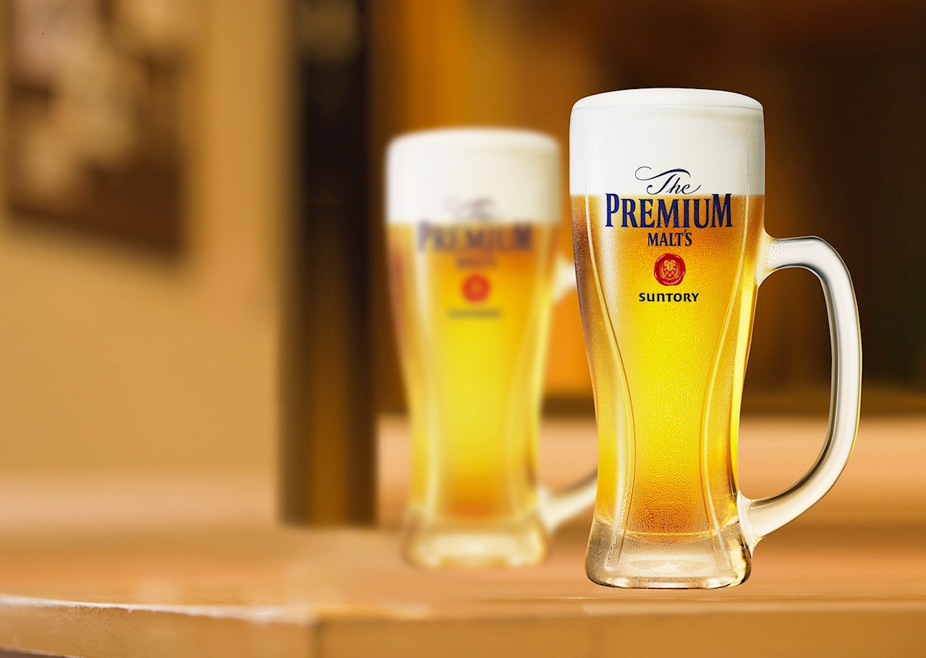

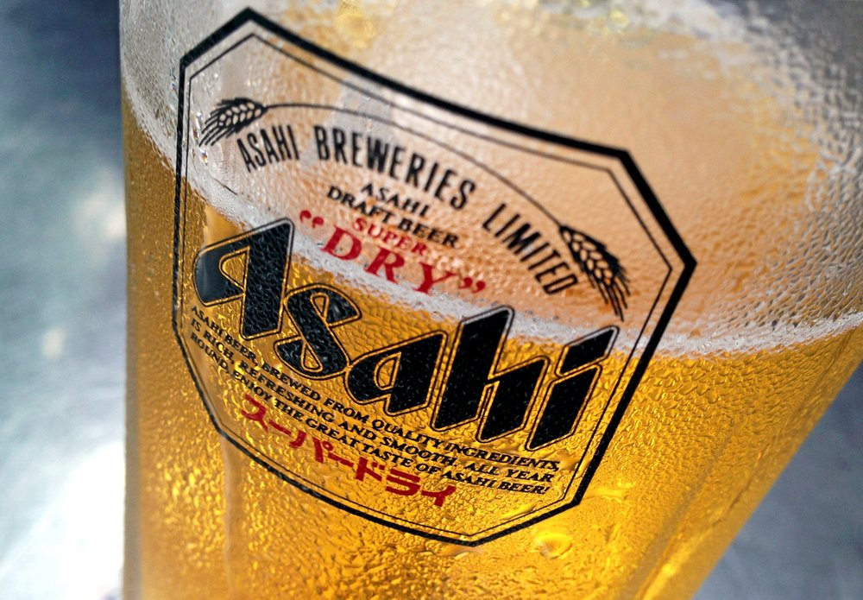


Special sake 特別酒
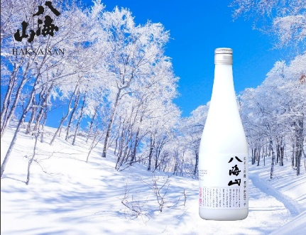
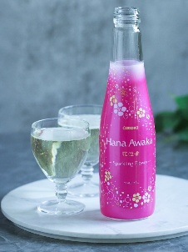
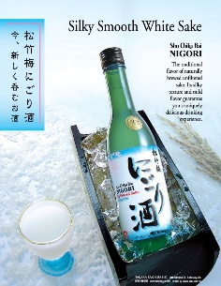

House Sake Nigori Yukimuro Hana awaka
SNV +3 SMV _20 SMV -1 SMV -60
300ml 17 375ml 15 250ml 15
720ml 35 750ml 25 720ml 95

Daiginjo 大吟醸
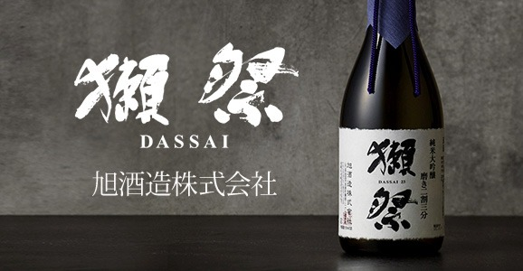
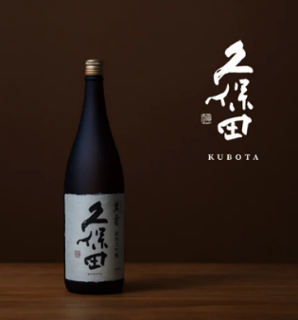
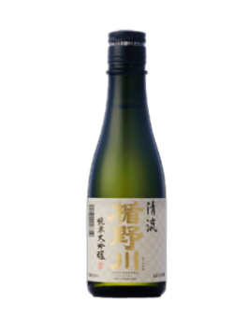
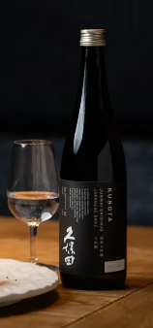
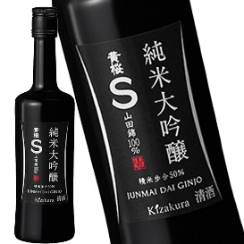

Kubota Manjyu Kizakura S Dassai 39 Tatenokawa Kubota JD
SMV +2 SMV +1 SMV +3 SMV +1 SMV +0
180ml 8 300ml 28 300ml 19 300ml 19
720ml 130 720ml 65 720ml 45

Ginjo 吟醸 Junmai 純米
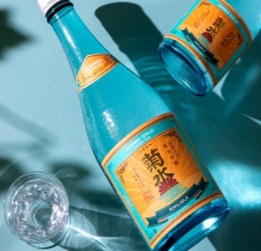
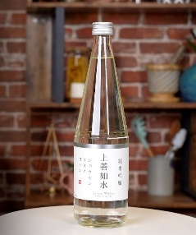
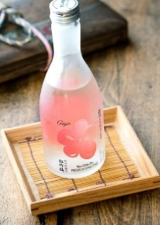
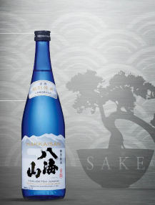
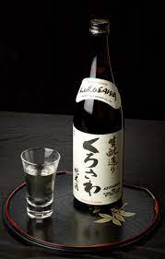

Kikusui Jozen White Sho-chiku-bai Hakkaisan Kurosawa
SMV+1 SMV +5 SMV +5 SMV +5 SMV+2
300ml 22 300ml 19 300ml 19 300ml 19
720ml 50 720ml 55 720ml 45
1800ML 90

BEER

Large Small
Asahi 10
Sapporo 10 Sapporo Light 7

SPECIAL BEER (From Japan)

Echigo (Niigata) 8
Asahi Draft 10
The Premium Malt’s 12
Orion (Okinawa) 10
Asahi Zero (Alcohol Free) 7

WINE

Glass Bottle
Chardonnay (Angeline) 12 36
Sauvignon Blanc 12 36
Cabernet Sauvignon (Francis Coppola) 15 45
Plum Wine 7 15

SOFT DRINK

Coke, Diet Coke, Sprite 3
Ramune Soda (Japanese Soda) 3
Iced Green Tea 3
Hot Green Tea 3
Sparkling Water 3

